Question 3:

The state feedback of the nonlinear and linear system are in form below.

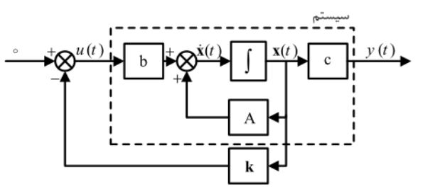

First, we designed the nonlinear system in Simulink,

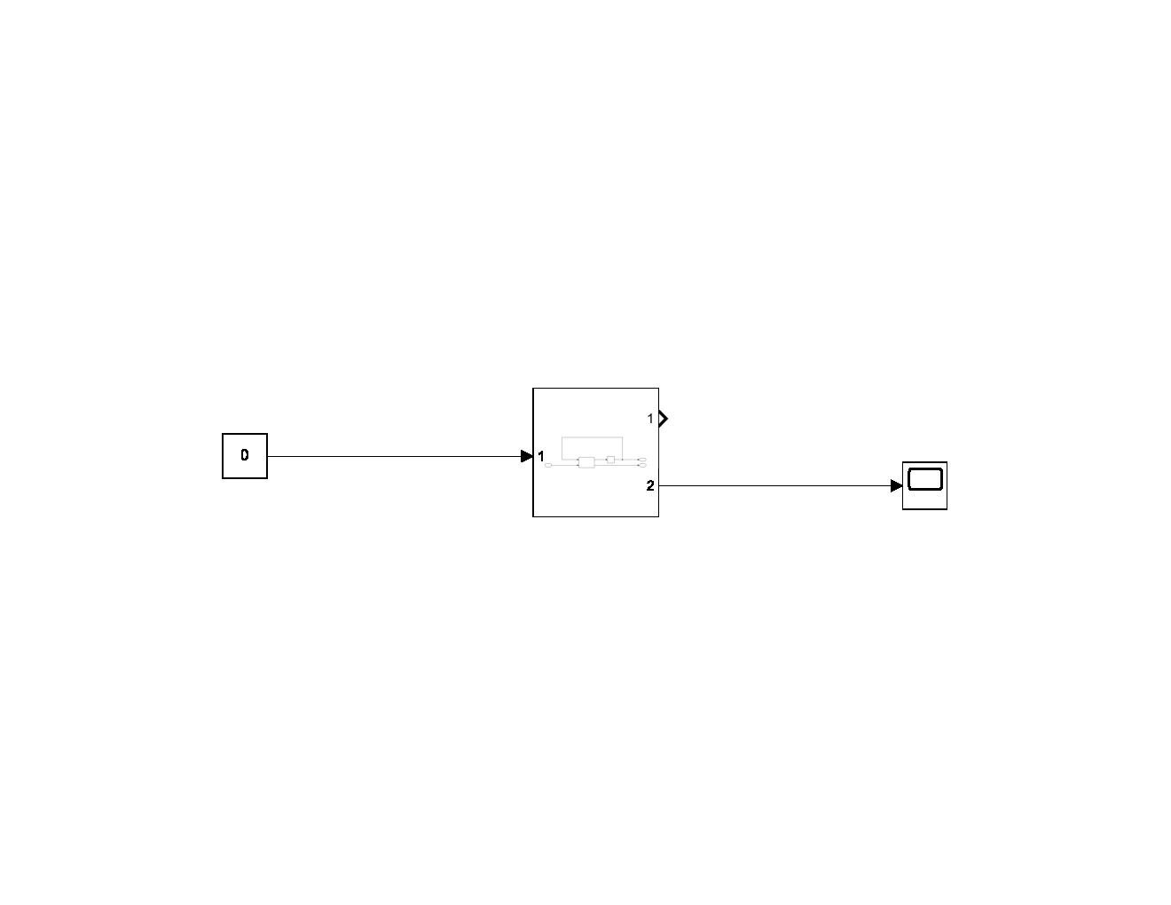

The subsystem is:

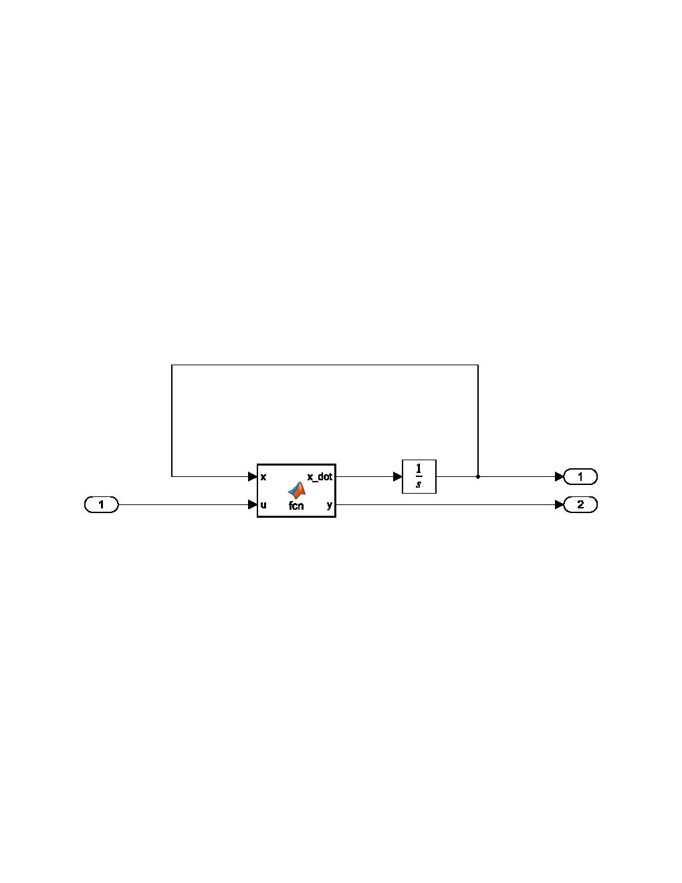

The MATLAB function calculate the and y.

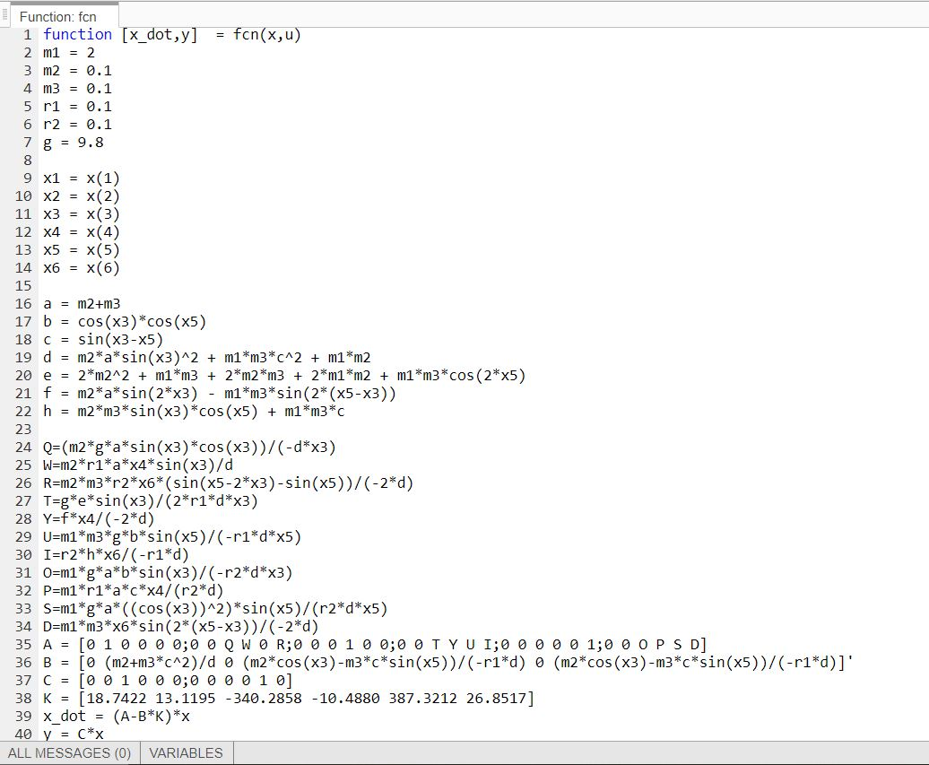

The output of the Simulink is:

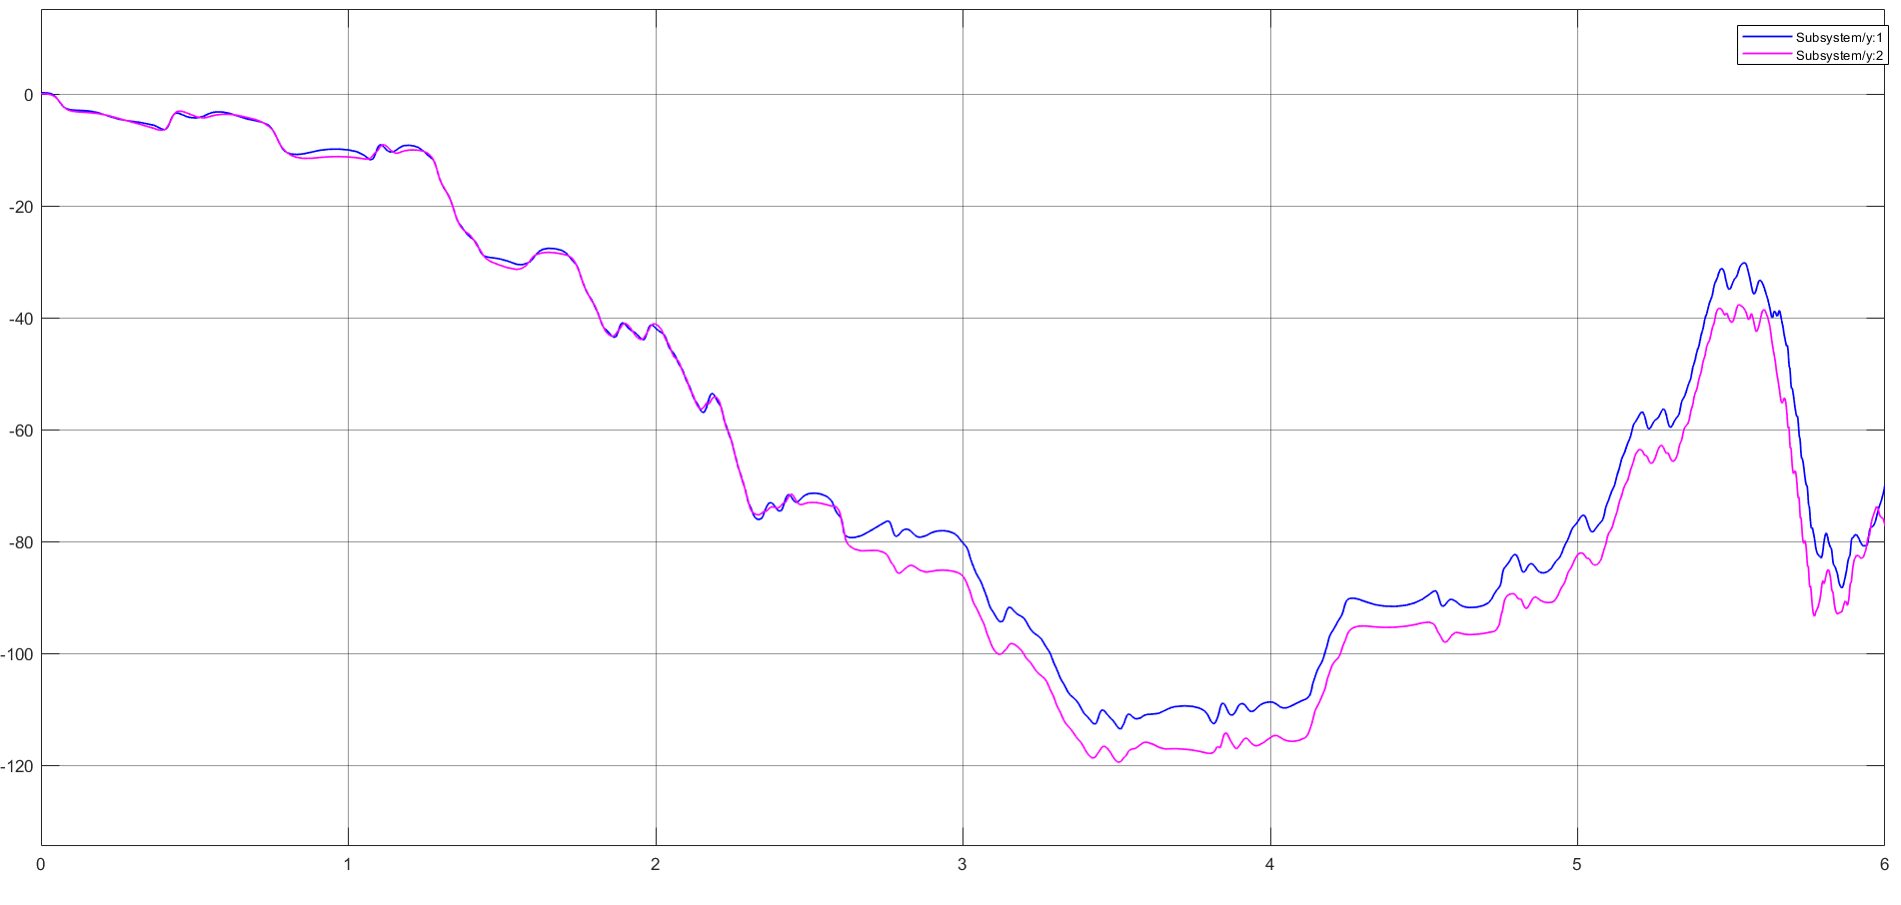

As we can see the regulation is satisfied.

Second, we design the linear system in Simulink:

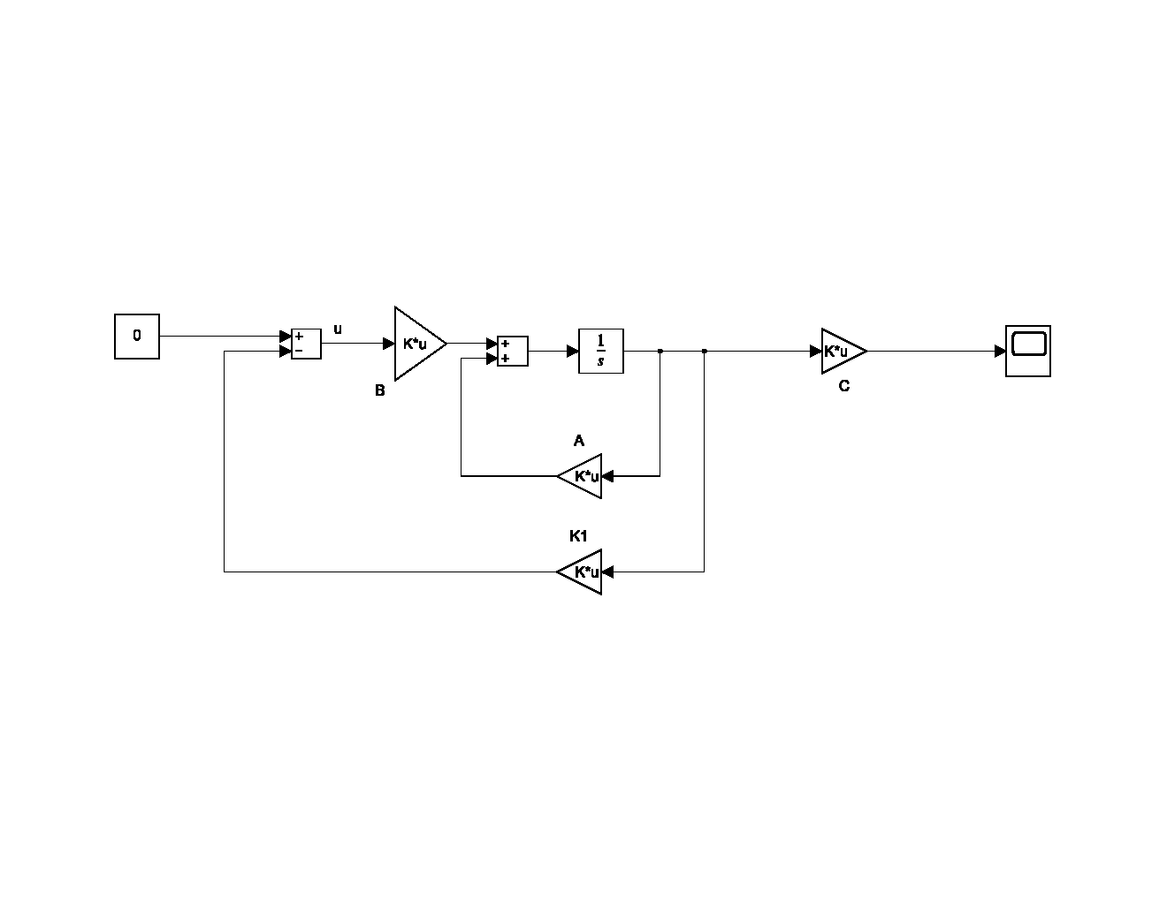

A, B and C had been defined in the previous section. The only parameter left is K1.

Our system, since rank(C(A,B))=6 and rank(O(A,C))=4 ,is controllable but not observable.

From desired poles of the system we have:



Chosen 

Then,



MATLAB code:

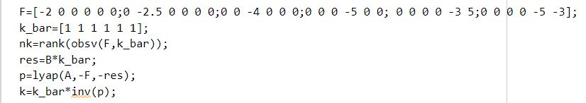

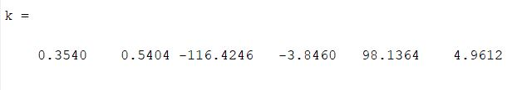

From the k we got from the code, Simulink design is complete. The result is:

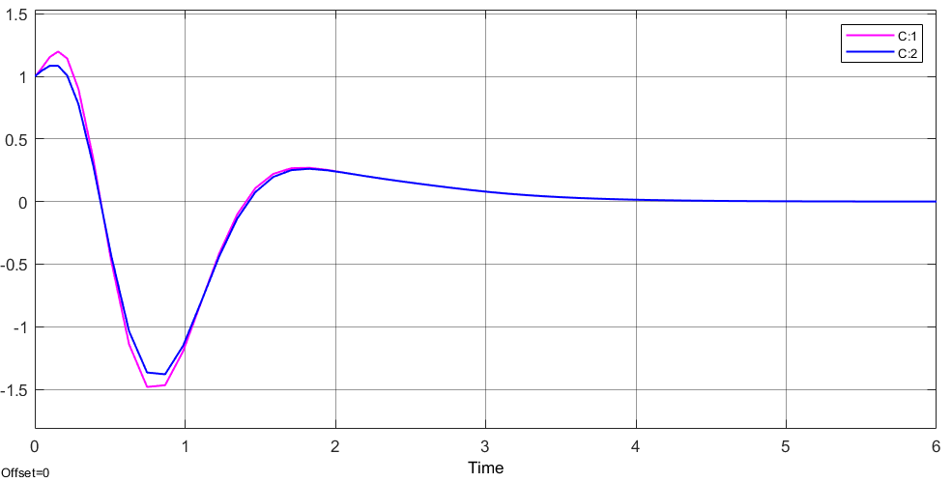

The regulation problem is satisfied.